**Project Proposal**

1.   **Project description**

The project is about an online food and restaurant suggestion website which shows a list of restaurants around the user location by default and registered users with an option to favorite, review restaurants and follow other users as well.  User also gets a notification from the friends of user whenever they make a review. User will also be able to search restaurants by typing in a specific location as well. Users can specify the food they want to eat and the application lists the restaurants which contains the food searched for. The restaurant search results can be sorted according to the ratings of the restaurant in descending order. The home page consists of a list of restaurants according to user’s device location. The homepage has two search boxes for food keyword and location. There will be two kinds of users 1) Registered User and 2) Guest user. Both users will have access to homepage and able to perform search operations for any location. Registered users have the privilege of writing reviews for restaurants and they are presented with an option to favorite and follow other users. User can register using the register page where the user information such as user credentials and is captured and stored in database. User logs in via login page by providing username and password. The website will be friendly interface which is highly interactive and responsive suiting various device.

**2.   Actors**

Registered User:

* User can search for food using keywords and any location
* User can view and write reviews and also rate the restaurants
* User has an option to get the nutrient information of a particular recipe of  a restaurant
* User can get a list of healthy items available from the menus of the restaurant retrieved

Guest User:

* User can search for food using keywords and any location.
* User can only view the reviews and ratings for the restaurant.

**3.   Architecture**

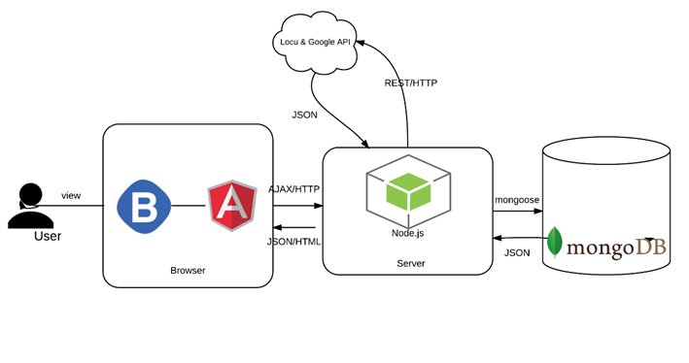

**4.   Use Case analysis**

a)    User Registration

* User opens the registration page of the application
* User enters the username, password, DOB, email, preferences
* Perform validation for few user fields and  display appropriate  message
* User confirm the details
* User clicks on Register button
* Display successful registration message on the same page

b)   User Login

* User opens the login page
* User fills in unique username and password
* Perform validation and display appropriate messages
* User clicks on login button
* Display home page with search results for the current location

c)   User profile update

* User opens the user profile page
* User edits the different profile field except username
* User clicks on update button
* Display successful profile update message on the same page

d) User food search

* User types in keyword or location or both  in respective search boxes provided in home page
* User either press enter or click on search button or presses enter key
* The home page is loaded with

e)   User review

* User clicks on a particular restaurant in the homepage
* User writes a review for that particular restaurant
* User clicks on submit button

f) User favorites a restaurant

* User clicks on a particular restaurant in the homepage
* User clicks on the favorite button on the details page

g) User Add friends

* User clicks on  find user tab on header
* User selects a user and clicks add friend button
* The selected user shows up in friends list and gets removed from all user list

**5.   Class Diagram**  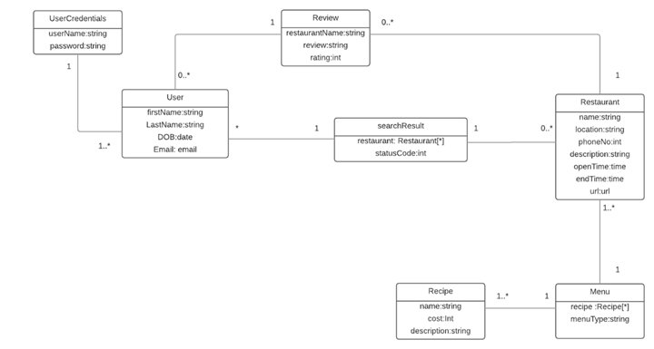

**6.   Wireframe**